****An Experimental Proposal to Quantify Particle Therapy Efficacy: Integrating Relative Biological Effectiveness Corrections and Tumor Response Modeling****

Haiyi Luo, Jinzhou Xie, Jingsong Gao, Tianhao Mu, Zhichen Tang

Bragg Vision

Chongqing Yucai Secondary School, Phillips Exeter Academy



1. **Introduction**

Beam therapy is a precise and effective cancer treatment that utilizes high-energy beams of particles—electrons, photons, protons, and ions—to kill tumors selectively. Different beams penetrate to different depths and deposit their energy in varying profiles, thus being best suited for the treatment of tumors located at different depths in the body.

But the cost of beam therapy is a significant barrier to research and optimization. Current testing and modeling approaches rely primarily on mathematical simulation or costly 3D-printed tumor models, not accessible and scalable. To address this, we present a low-cost artificial *non-biological* tumor model that employs fluorescence quenching to image real-time beam interactions.

Our experiment will show the utility of this artificial tumor model and how it can quantitatively measure the therapeutic effect of different beams(specifically electron and proton beams). In providing an inexpensive and scalable method to test beams, we hope our study will be able to find its place in larger studies to further improve treatments.

1. **Aim of experiment**

We aim to experiment with proton beams with respect to electron beams in an non-biological radiation-sensitive tumor in terms of measurements of dose deposition and scattering patterns. By varying beam types and tumor thickness, we will compare experimental data with MATLAB simulations, optimize our theoretical models, and try to find the best beam type and beam energy for different tumor depths. The expected results would improve cancer treatment planning, optimizing tumor targeting while minimizing collateral damage to healthy tumor tissues.

1. **Previous Results**

**III.1 Theory**

Let the tumor region be , and the particle beam flux be . The multi-scale coupling can be expressed as:

Where the variables and their dimensions are:

|  |  |  |
| --- | --- | --- |
| Φ(**r**,*E*,*t*) | ​****Particle flux****: Number of particles per unit area, energy, time, and solid angle. | cm−2⋅eV−1⋅s−1 |
| *t* | Time | s |
| **r** | Spatial position (3D coordinates) | cm |
| *E* | Particle energy | eV or MeV |
| *D*(**r**,*E*) | ​****Diffusion coefficient****: Describes how easily particles diffuse in the medium. | cm2/s |
| *S*(**r**,*E*) | ​****Source term****: Rate of particle production at position **r** and energy *E*. | cm−3⋅eV−1⋅s−1 |
| Σ(*E*′→*E*) | ​****Macroscopic scattering cross-section****: Probability of a particle scattering from energy *E*′ to *E*. | cm−1 |
| *μ*(*E*) | ​****Absorption coefficient****: Probability of particle absorption (e.g., ionization, nuclear reactions). | cm−1 |
| *R* | Radius of the tumor | cm |

Based on the flux, we then calculated the energy distribution, dose distribution and angular scattering of protons, electrons and photons. We used Matlab to simulate them for the three particles(Appendix1&2).

**III.2 Verification**

The performance of beam therapy can be defined as the effectiveness of the radiation beam in delivering precise dose deposition to the tumor while minimizing damage to surrounding healthy tissues, evaluated through metrics such as penetration depth and dose conformity, which we will discuss in part V.2.4.

In order to experimentally examine the performance of beams inside the tumor, we need to design a tumor model that

1. acquires properties similar to human tissue (density, layers, radiation absorption);
2. has additional properties that visualizes the effect of radiation;
3. does not contain biological materials compatible with T-9 Beamline constraints.

to assess depth-dependent interactions.

Our design of the tumor uses graded gelatin-agar matrices to replicate the density and hydration gradients between necrotic and healthy tissues.Powders of nuclear yellow(riboflavin) are mixed in the necrotic layer to track florescence quenching and pH change, while litmus sodium embedded artificial plasma-filled vasculature to simulate blood vessel responses to radiation. The effect of radiation can be clearly seen by florescence decay in the tumor core(florescent green bluish-purple), and plasma diffusion in the vascular network across layers(Appendix3).

The focused ion/electron beams of FIB/SEM(Scanning Electron Microscope-Focused Ion Beam) systems can partially replicate key aspects of beam-therapy through controlled dose deposition at microscale resolution, which will be discussed in detail for each type of radiation.

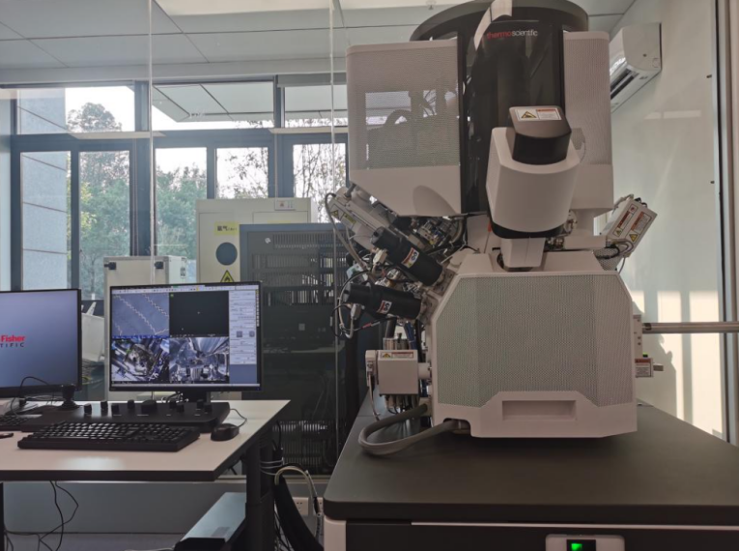

Fig.1 The SEM-FIB system we borrowed at the Analytical and Testing Center of Chongqing University

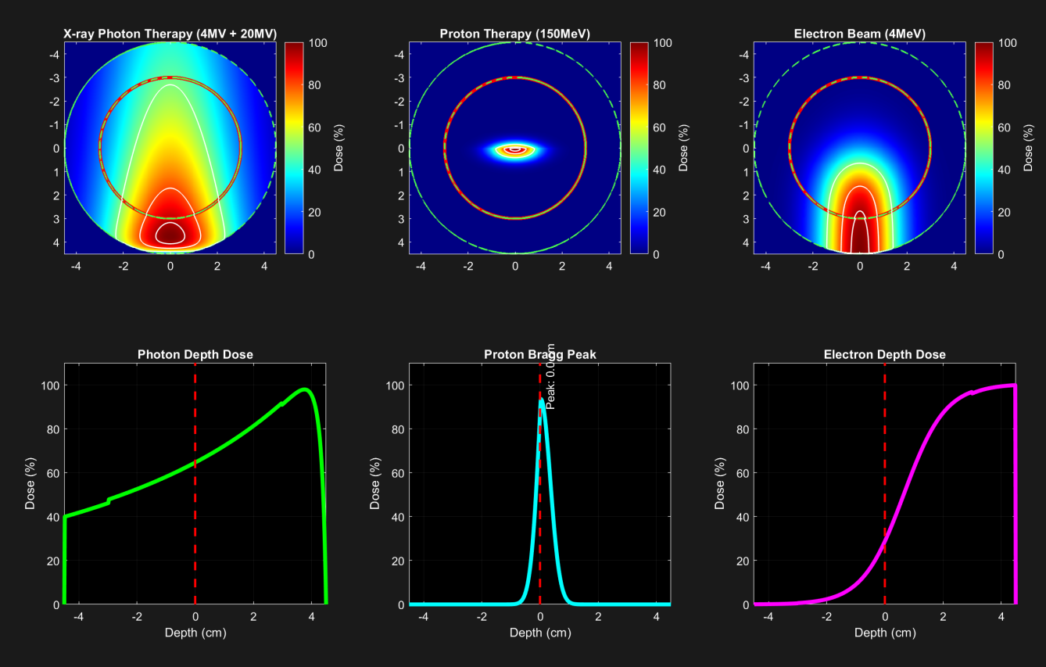

Fig.2 Simulated dose deposition for photons, protons, and electrons inside the tumor

**III.2.1 Florescent-Quenching by X-ray Radiation**

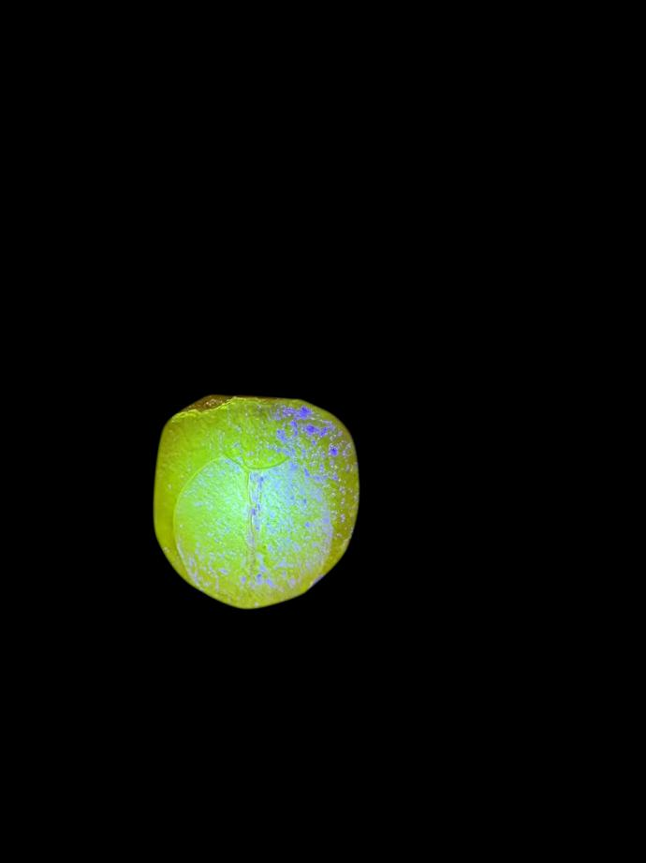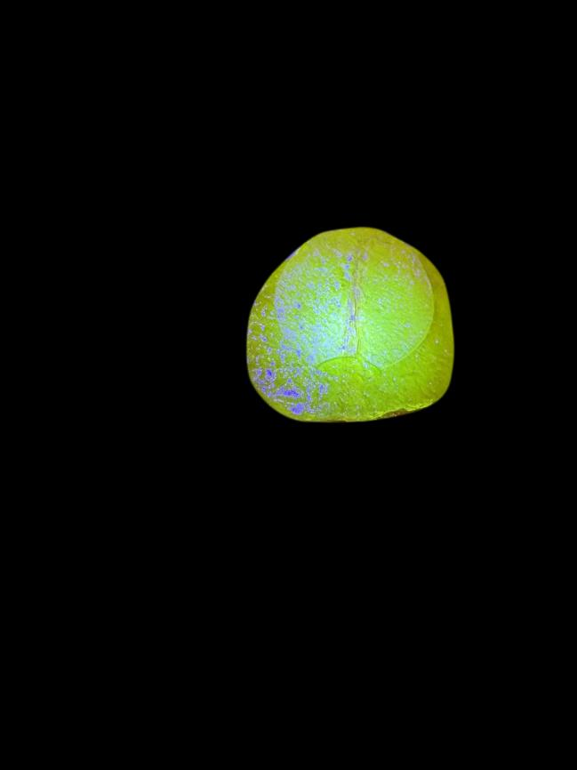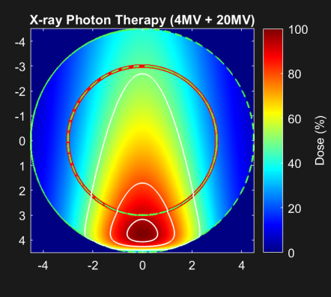

Fig.3 X-ray induced florescence quenching in accordance to the simulated energy deposition pattern

X-ray effects are indirectly modeled through Bremsstrahlung and secondary electrons that induce radiolytic reactions similar to kV-photons, but lack the uniform depth-dose distribution and megavoltage penetration of LINAC-derived X-rays[6].

X-ray induce gradual acidification(pH~6.0) throughout the tumor, reflected in Raman spectra by the complete 1600→1620 cm⁻¹ litmus peak shift and carbonate peak reduction[5].

The necrotic layer’s riboflavin shows rapid florescence quenching due to direct ionization by high-energy photons, correlating with dose deposition. Artificial plasma vessels exhibits localized leakage from radiation-weakened vessel walls, visible as fluid diffusion into surrounding matrices.

**III.2.2 Florescent-Quenching by Electrons**

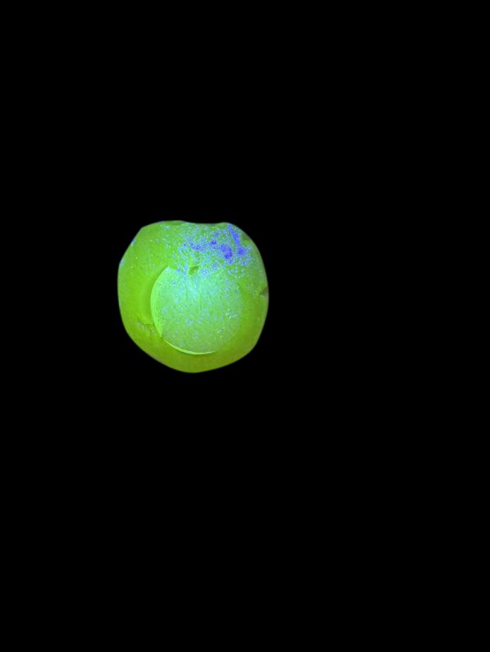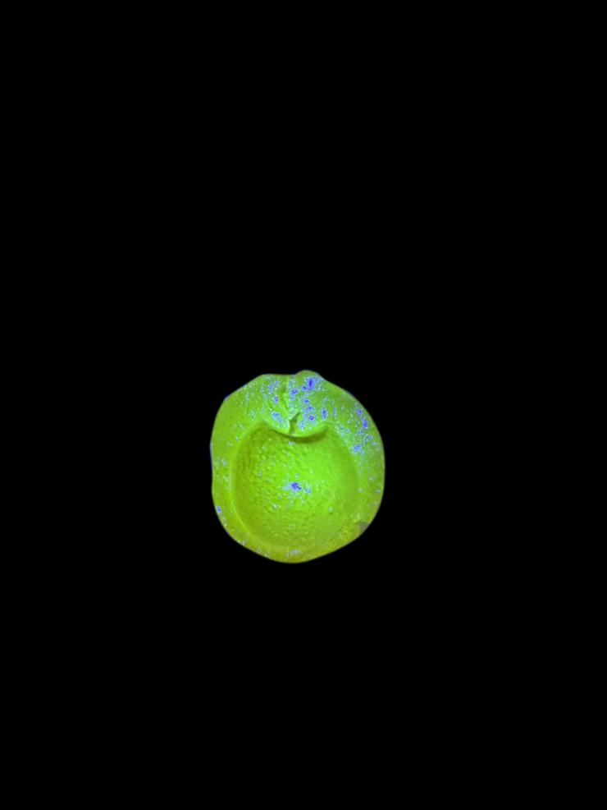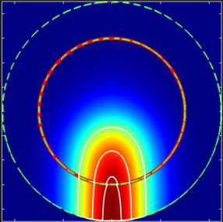

Fig.4 Electron-induced florescent quenching in accordance to the simulated energy deposition pattern

For electron beams, the SEM’s 1-30 keV electrons mimic superficial treatments by generating localized ionization clusters and secondary electrons analogous to DNA damage mechanisms[4].

Electrons cause localized, heterogeneous acidification (pH ~5.5) via concentrated ionization, shown by broadening of the 1600 cm⁻¹ litmus peak into 1605 cm⁻¹ and appearance of a new 1350 cm⁻¹ radical peak[5].

Shallow-penetrating electrons predominantly activates the healthy layer’s litmus system, causing fast color shifts from concentrated ionization near the surface. Riboflavin in deeper necrotic regions show partial quenching from scattered low-energy electrons. Plasma-filled vessels display minor leakage due to superficial vascular damage.

**III.2.3 Raman Spectra Analysis**

We are able to examine the effect of electrons and photons (but not protons) by analyzing the change in pH induced by radiations. The pH change alters molecular structures (like protonating litmus or degrading riboflavin), which modifies their vibrational modes and thus shifts or quenches their characteristic Raman peaks.

The spectra we obtained effectively capture the distinct molecular responses of the tumor model to different radiation types, demonstrating its utility as a predictive tool for beam therapy outcomes. In the unirradiated tumor(blue curve), the prominent peak at 1550cm⁻¹ corresponds to intact riboflavin molecules, specifically the C-N and C=C stretching vibrations of its isoalloxazine ring. This is accompanied by a sharp 1600cm_1 peak from the aromatic C=C bonds in litmus, which remains in its blue, deprotonated state under neutral pH(~7.4). The peak carbonate signal at 1120cm⁻¹ and stable gelatin matrix signature at 1300cm⁻¹ further confirm the structural integrity of the synthetic tumor under baseline conditions.

X-ray irradiation(red curve) causes about 50% drop in riboflavin signal(1550cm⁻¹ ) and a shift to 1620cm⁻¹ (acidic litmus), indicating oxidative damage and pH drop to ~6.0.

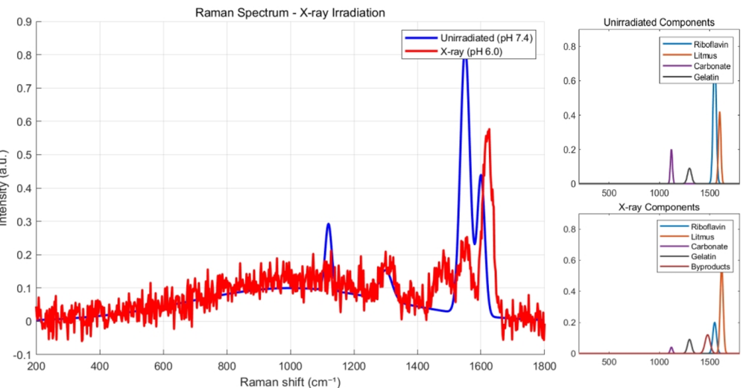

Fig. 5 Raman Spectra of the tumor before and after X-ray irradiation

Electron beams(purple curve) produce partial riboflavin quenching(30% at 1550cm⁻¹ ) and a broad 1605cm⁻¹ peak, showing surface-weighted damage and pH heterogeneity(~5.5). A unique 1350radical peak appears with electrons.

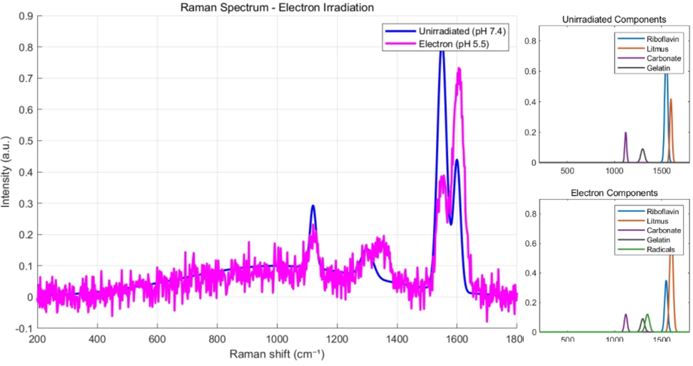

Fig.6 Raman spectra of the tumor before and after electron irradiation

1. **Experiment Design**

We aim to quantify and compare the penetration characteristics of **pure proton and electron beams** in tumor-like phantoms, focusing on **dose deposition** **profiles** (dose deposition per unit mass) and **lateral scattering**. The experiment will validate the feasibility of isolating single-particle beams using ​**CERN’s T9 beamline** and provide data to optimize radiotherapy protocols. By correlating measured energy loss and scattering angles with simulations (e.g., ​**GEANT4**), we will establish a framework for precision beam delivery in cancer treatment.

**IV.1 Beamline Configuration**

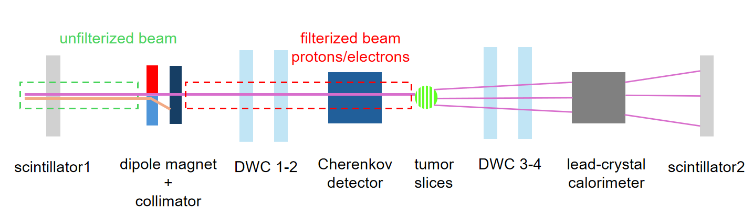

Fig.7 Beamline configuration [7]

****Upstream Beam Purification****:

* ****Dipole Magnet + Collimator****: Filters particles by momentum (Δ*p/p* = ±2%).
* ****Particles (singled out for each experiment)****
* ****Protons****: Select 1.5–2.5 GeV/c momentum range.
* ****Electrons****: Select 4 GeV/c momentum range.
* ****Threshold Cherenkov Detector****:
* ****Proton mode****: Uses low-refractive-index gas (nitrogen, *n* = 1.0003) to veto faster particles (π⁺, μ⁺).
* ****Electron mode****: Uses high-refractive-index acrylic (*n* = 1.5) to tag electrons while rejecting slower particles (π⁻, μ⁻).
* ****Scintillator Trigger****: Synchronizes data acquisition with beam pulses.

****Target Region****:

* ****Tumor Phantom****: Mounted on a motorized stage for precise positioning.
* Non-biological radiation-sensitive tumor simulates human tumor tissue.
* ****Beam Monitoring****:
* ****Drift Wire Chambers (DWCs 1–2)****: Measure incoming beam trajectory with ±1 mm spatial resolution.

****Downstream Tracking****:

* ****DWCs 3–4****: Track outgoing particles to calculate lateral scattering angles (Δθ).
* ****Lead Glass Calorimeter****: Measures dose deposition for electrons.
* ****Momentum Analysis Magnet + DWC****: For protons, measures post-target momentum loss via trajectory deflection.

**IV.2 Experiment Workflow**

****Proton Experiment****:

* ****Beam Setup****: Select 1.5–2.5 GeV/c protons; activate Cherenkov veto.
* ****Tumor Scan****:
* Start at 5 mm thickness; increase in 2 mm steps.
* At each step, record:
  + - dose deposition in calorimeter rear segments.
    - Residual momentum via DWC 3–4 deflection.
    - Scattering angle (Δθ) from DWC 1–2 and DWC 3–4 trajectories.
* ****Termination****: Stop when dose deposition in the calorimeter drops to zero (Bragg peak exceeded).

****Electron Experiment****:

* ****Beam Setup****: Select 4 GeV/c electrons; activate Cherenkov tagging.
* ****Phantom Scan****:
* Use the same incremental tumor thickness steps.
* At each step, record:
  + - dose deposition in calorimeter rear segments.
    - Scattering angle (Δθ) from DWC trajectories.
* ****Termination****: Stop at full tumor penetration.

**IV.3 Data Analysis**

The dose deposition and scattering angles for protons and electrons are derived as correlated detector data that are scanned incrementally through different phantom thicknesses. For each particle, energy data is acquired in synchrony with the trajectory data, allowing for a direct correlation of energy loss to angular deflections. Simulations of both angular scattering(Fig and Fig) and dose deposition(Fig.1) are given for both particles.

**IV.3.1 Proton Analysis**

The mapping of proton dose deposition is done by means of a depth-dose curve, identifying the Bragg peak and FWHM incrementally with phantom thickness changes in 2 mm steps. The scattering angles Δθ, determined from shifts in the trajectory of the DWC, are calculated as

The other parameter, residual momentum, is thus validated with respect to the DWC deflections against Bethe-Bloch predictions with corrections for energy straggling. Mismatched events of dose deposition such as from nuclear fragmentation are filtered out using calorimeter threshold settings.

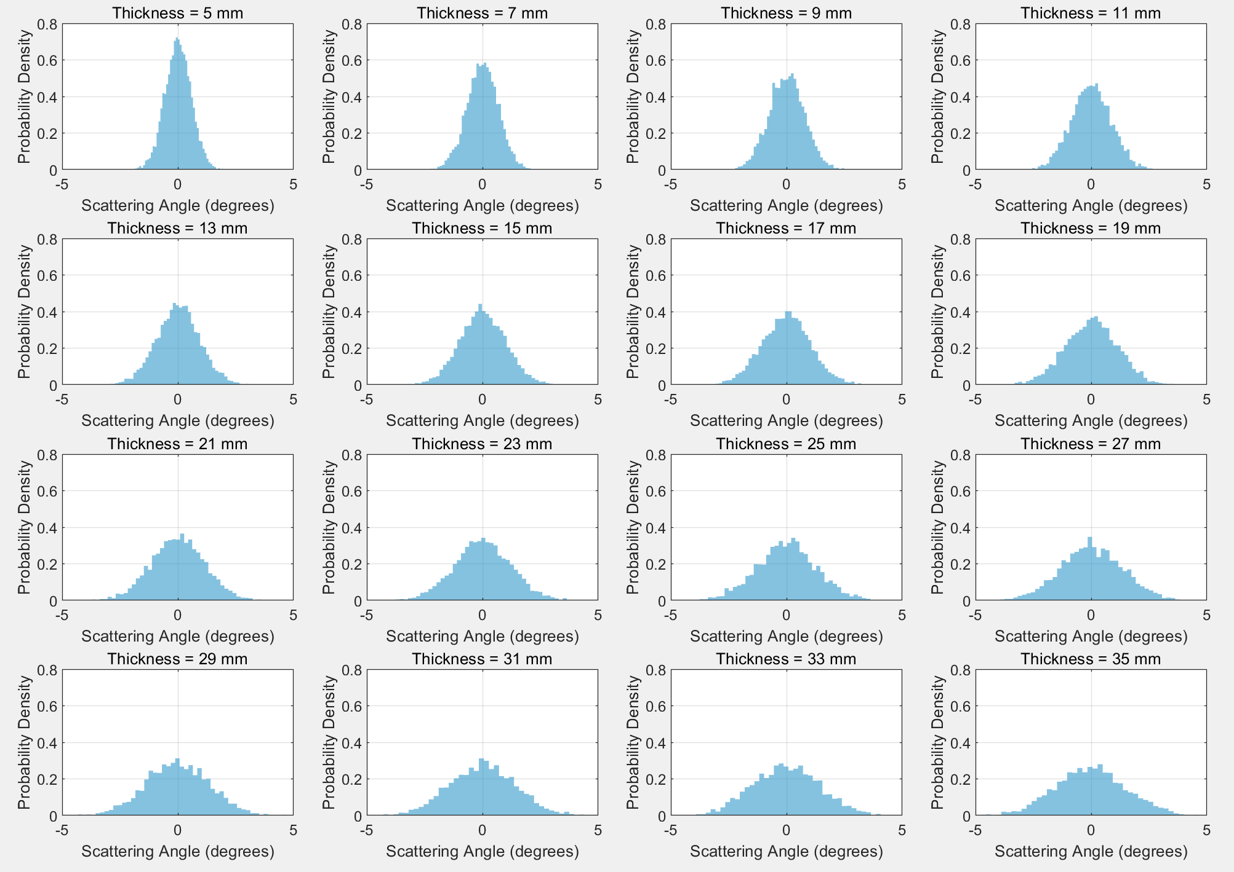

Fig.8 Normalized angular scattering simulation of protons

**IV.3.2 Electron Analysis**

Electron energy loss follows an exponential attenuation profile fitted to extract attenuation coefficient (μ). Scattering angles, referenced to Molière theory, are treated in relation to multiple Coulomb scattering. The Cherenkov veto signals exclude any potential outliers from bremsstrahlung or delta electrons. A lateral spread of electrons is analyzed by correlating scattering angles to depth with information regarding energy loss reverses.

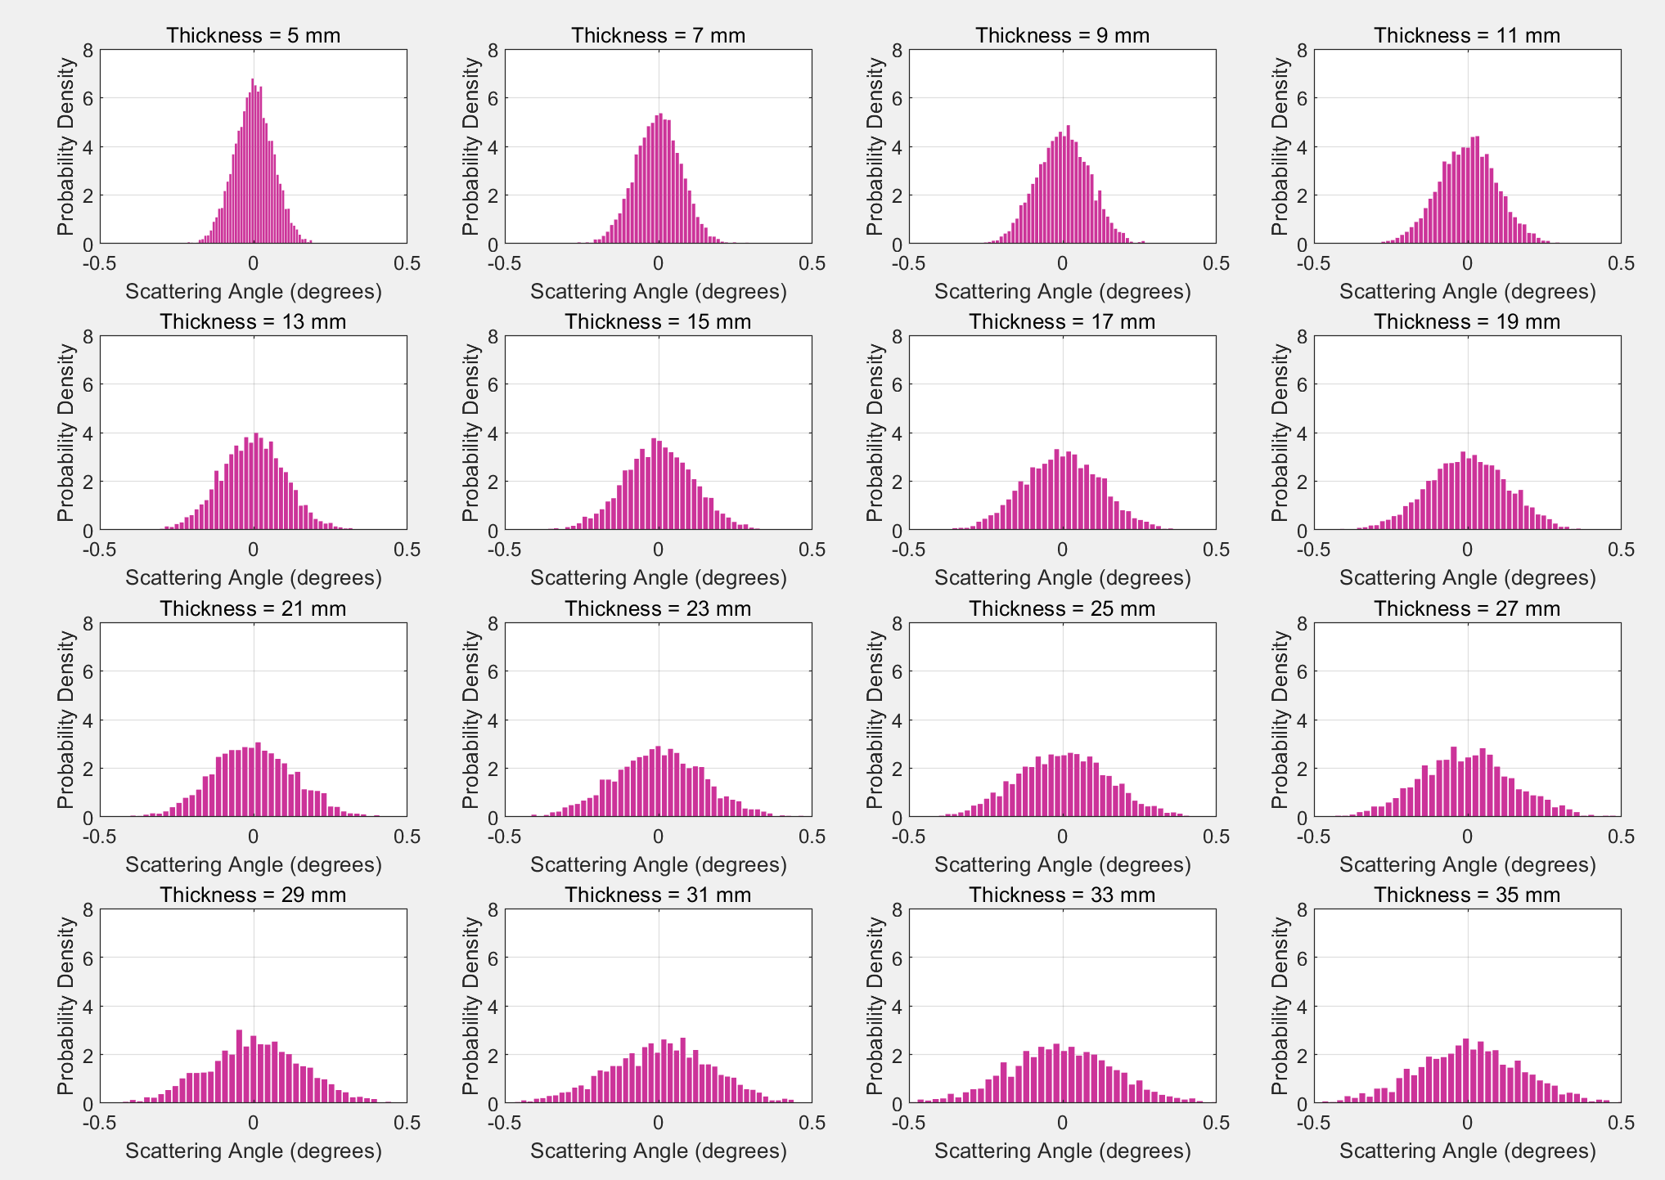

Fig.9 Normalized angular scattering simulation for electrons

**IV.2.3 Uncertainty Quantification**

Systematic uncertainties include calorimeter energy resolution (±1.5%), DWC alignment (±0.2°) for protons, and shower fluctuations (±2.0%), scattering noise (±0.5°) for electrons. A Monte Carlo error framework merges these uncertainties to ascertain that the parameters of interest, such as Bragg peak position (±0.5 mm)and attenuation coefficient (±3%), are reliable.

**IV.2.4 Therapeutic Effectiveness**

We define the performance of beam therapy as the effectiveness of the radiation beam in delivering precise dose deposition to the tumor while minimizing damage to surrounding healthy tissues. Referring to Zheng, D et al[2], we model tumor response by integrating the physical dose distribution with biological sensitivity. The linear-quadratic(LQ) model serves as the foundation that relates dose to radiation and cell killing, with lethal double-strand breaks () and accumulation of sublethal damage ().

We account for dose by relative biological effectiveness(for protons, /=RBE1.1-1.5, for electrons, REB1), symbolizing enhanced potency.

We predict tumor control probability (TCP) and normal tissue damage probability (NTCP), balancing effectiveness versus safety.

[2], where is the number of initial live cells in the tumor

[3], where t is the normalized dose difference and u is a dummy variable used in the cumulative normal distribution.

TCP>90%, shows high likelihood for tumor control [2], NTCP<5% shows minimal risk to healthy tissues [3].

1. **What We Hope to Take Away**

It was expected that this experiment would lead to fundamental insights into the interaction of proton and electron beams with tumor tissues at various energy levels. In comparing their dose deposition and scattering behavior, we hope to better understand the physics associated with modern means of radiation therapy.

Aside from gaining experience working on experimental particle physics at CERN-from beamline operation to data taking, it promises to be totally invaluable. We are looking forward to learning critical skills in detector calibration, Monte Carlo simulation validation, and statistical analysis of particle interactions.

Most importantly, hopefully, this research will give relevant data for improvements in accuracy and effectiveness with which particle therapy treatments deliver. Some of the knowledge gained will also lend itself to improving treatment planning for different tumor types and depths, and on that, we hope, some day to benefit further cancer patients around the world.

1. **Outreach Activities**

Our Cosmic Ray Observation Club wishes to engage students with the exhilarating fields of particle physics, astrophysics, and research by studying cosmic ray, providing a window into fundamental physics, from subatomic interaction to extreme astrophysical phenomenon.

Our club engages in outdoor observations, the construction of simple detectors, cosmic ray event analysis, and discussion of implications in both fundamental science and real-life applications, including space exploration and atmospheric physics.

Moreover, we actively promote collaboration with working scientists and institutions by inviting distinguished speakers, such as the chief designer of the Large High Altitude Air Shower Observatory(LHASSO) to talk about high-energy physics, detector technologies, and cosmic ray sources. These activities seek to partner high school students with leading-edge physics, inspiring future generations of scientists and thinkers along the way.

1. **Acknowledgement**

We would like to thank our physics teacher, Mr. Chengxin Zhang for supporting our Beamline for Schools Competition and helping us connect with the Analytical and Testing Center(ATC) at Chongqing University. Thanks to Mr. Yingzhou Huang at ATC, we are able to access the Raman spectrometer and FIB-SEM system to quantify the florescence-quenching effect of in our artificial tumor. Our proposal would not have been possible without Ms Wenli Zheng(of the Chinese Institute of High Energy Physics) and Mr. Huihai He(of LHASSO) for their guidance for experimental design.

**References**

1. Massey, A., Stewart, J., Smith, C. *et al.* Mechanical properties of human tumour tissues and their implications for cancer development. *Nat Rev Phys* **6**, 269–282 (2024). <https://doi.org/10.1038/s42254-024-00707-2>
2. Zheng, D., Preuss, K., Milano, M.T. *et al.* Mathematical modeling in radiotherapy for cancer: a comprehensive narrative review. *Radiat Oncol* **20**, 49 (2025). <https://doi.org/10.1186/s13014-025-02626-7>
3. Nuttens, V. E., Nahum, A. E., & Lucas, S. (2011). An NTCP Analysis of Urethral Complications from Low Doserate Mono- and Bi-Radionuclide Brachytherapy. *Prostate cancer*, *2011*, 128360. <https://doi.org/10.1155/2011/128360>
4. R.F.Egerton, P.Li, M.Malac (2004). Radiation damage in the TEM and SEM. Micron, volume 35, Issue 6, 2004. [https://doi.org/10.1016/j.micron.2004.02.003](https://doi.org/10.1016/j.micron.2004.02.003" \o "Persistent link using digital object identifier" \t "https://www.sciencedirect.com/science/article/abs/pii/_blank)
5. Paidi, S. K., Diaz, P. M., Dadgar, S., Jenkins, S. V., Quick, C. M., Griffin, R. J., Dings, R. P. M., Rajaram, N., & Barman, I. (2019). Label-Free Raman Spectroscopy Reveals Signatures of Radiation Resistance in the Tumor Microenvironment. *Cancer research*, *79*(8), 2054–2064. <https://doi.org/10.1158/0008-5472.CAN-18-2732>
6. Ana M.Diez-Pascual., Diego Garcia-Garcia et al. Determination of Riboflavin Based on Florescence Quenching by Graphene Dispersions in Polyethylene Glycol. (2016), [https://doi.org/10.1039/C5RA25547C](https://doi.org/10.1039/C5RA25547C" \o "Link to landing page via DOI)
7. “Beams and Detectors”

**APPENDIX**

1. **Particle-Specific Models**

| ****Particle**** | **Energy Loss (dE/dx)** | **Dose Distribution** | **Angular Scattering** |
| --- | --- | --- | --- |
| ​****Proton**** | Bethe-Bloch ionization | Bragg peak integral | Molière multiple scattering |
| ​****Electron**** | Bethe-Bloch ionization(Collisional + radiative) | Exponential depth decay | Molière multiple scattering |
| ​****X-ray**** | Bethe-Bloch ionization(Linear attenuation coefficient) | Exponential + secondary electrons | Klein-Nishina cross-section |

**dose deposition**

We can describe the physical interaction between a massive particle beam (of type j) and the tumor via the Bethe-Bloch equation:

Where

is the classical electron radius

= electron mass

is the atomic number and mass ratio of the tissue

is the particle’s charge state

is the proton velocity relative to light speed

: Lorenz factor

: the mean excitation potential of target tissue

is the density effect correction

: tissue density

According to the Bethe-Bloch equation, different particles radiate away their energy accordingly. Protons have very low radiative interaction and thus interact mainly through collision and coulomb forces. Therefore, they deposit energy more effectively with the electrons in the tumor when they are moving slower, which is at the end of their trajectories.

For massless photon particles, their energy loss is governed by the Linear Attenuation Coefficient:

Where

is Avogadro’s number

is the photoelectric cross-section

is the pair production cross-section

1. **Dose Distribution**

For protons, dose accumulates along the proton’s path, peaking at where is maximized(called the Bragg peak) before rapid energy lost:

Where

is the proton flux at energy E

is the path length along beam direction

is the Dirac delta enforcing Bragg peak localization

Electron dose peaks near the surface(due to rapid scattering) and decays exponentially with depth:

Where

is the electron attenuation coefficient

X is the depth in tissue

For X-ray photons, dose is deposited indirectly via secondary electrons(Compton, photoelectric). Exponential attenuation governs depth-dose profile:

Angular scattering

The angular scattering of massive particles (protons, electrons), is governed by the Molière multiple formula:

Where

j MeV is the scattering cross-section integration over atomic fields, but differ due to particle mass, interaction type and radiation length scaling.

x is the material’s thickness

is the radiation length for tissues(36.1g/cm^2), and

p is the momentum of particle j.

For massless particles of photons, scattering angles depend on initial energy R and the follow Klein-Nishina distribution, which reduces to Thomson scattering at relatively low energies:

Where

is the scattered photon energy

is the scattering angle.

1. **Making of the Non-Biological Tumor**

#### Tumor Core:

* Prepare small circular rubber molds, syringes (without needles), and small sticks in advance.
* Mix gelatin, agar, and water in a mass ratio of 2:1:10 in a pot. Stir thoroughly and turn off the heat once fully dissolved. While still hot, add 3 g of riboflavin and stir evenly.
* Using a syringe without a needle, transfer the mixture into the mold. Insert a stick into the center, similar to making a lollipop. Before the mixture solidifies, insert two pieces of pH test paper: dip one briefly in the yellow solution and refrigerate; sandwich the other in the core and place the entire mold into the freezer to solidify.
* Once frozen, demold the tumor core and allow it to soften slightly at room temperature.

#### Tumor Necrotic Layer:

* Prepare a transparent balloon and a dropper.
* Mix gelatin, agar, water, and baking soda in a ratio of 2:1:5:2. Stir thoroughly. While still hot, gradually add litmus solution using a dropper until the overall solution turns blue, then stop.
* Allow the mixture to cool slightly but not solidify. Insert the previously prepared tumor core, still attached to the stick, into the balloon.
* Using a syringe, inject the necrotic-layer solution into the balloon, ensuring the tumor core is fully encapsulated.
* Insert a strip of pH test paper into the necrotic layer and keep another piece as a control.
* Allow the structure to cool and solidify.

1. **Schedule Arrangement**

The experiment will run over ​****10 days**** with the following workflow:

| **​**Day**** | **​**Tasks**** |
| --- | --- |
| ​****1**** | ​****Beamline Setup & Calibration****: |
|  | - Align dipole magnets, collimators, and detectors. |
|  | - Tune beam momentum for proton (1.5–2.5 GeV/c) and electron (4 GeV/c) modes. |
|  | - Validate Cherenkov detector thresholds with calibration runs. |
| ​2 | ​****Control Runs****: |
|  | - Acquire baseline data *without* the phantom to characterize intrinsic beam divergence and detector noise. |
| ​3****–5**** | ​****Proton Beam Data Collection****: |
|  | - Perform 3 phantom thicknesses (5 cm, 10 cm, 15 cm) at 2 GeV/c. |
|  | - Record scattering angles (Δθ) and Bragg peak positions via calorimetry. |
| ​6****–8**** | ​****Electron Beam Data Collection****: |
|  | - Repeat phantom thickness tests at 4 GeV/c. |
|  | - Measure continuous energy loss profiles and lateral scattering. |
| ​9 | ​****DESY Cross-Check (Optional)****: |
|  | - Validate electron results with DESY’s 6 GeV pure electron beam (no Cherenkov filtering required). |
| ​10 | ​****Contingency****: Address systematic errors (e.g., beam instability, phantom misalignment). |

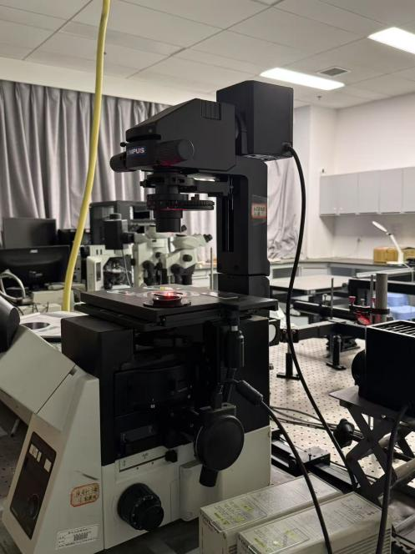

The Raman spectrometer we collaborated to construct at the Analytical and Testing Center of Chongqing University

1. **Additional Tumor Feature**

Using a fine syringe, we carefully inject simulated blood (commercially available as "fake blood") into the core to mimic microvasculature (the finer the syringe, the better) to simulate the diffusion of blood with and without radiation. If radiated, blood diffusion speeds up, which is clearly observed and therefore can be used to qualitatively verify the curing effect of beams.

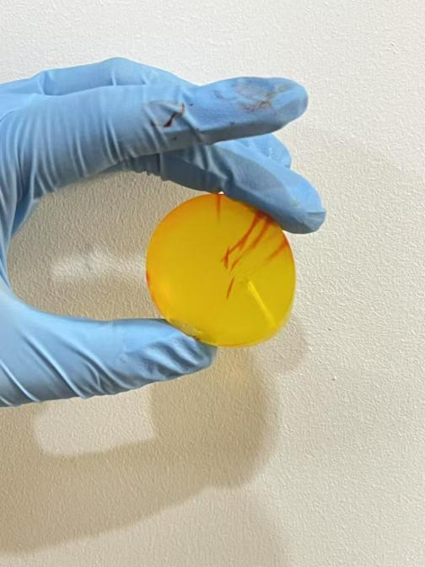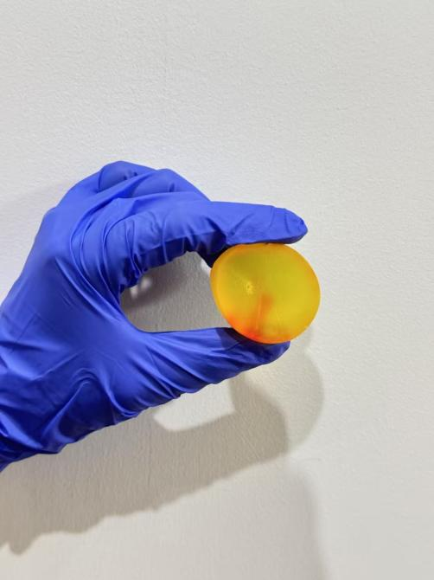

The same tumor before UV radiation(left) and after radiation